Grandpa’s Photo Album

I found a photo album my Grandpa had made, full of his houses, his family, and the important parts of his life. My Grandfather David divorced my Nana Maureen when my mother was young, and a connection was lost there, so I never grew up knowing much about him. Whilst his scrapbook is brief, it has provided me insights into who he was.

There were photos of him as a baby, his extended family, my mother and uncle as young children, and photos of his adventures in his 40s and 50s from ski trips to rollerblading accidents. The photos were in an old album that had adhesive paper, and plastic sheets covering it, so when the photos were placed between the two. However the adhesive has grown old and no longer holds some things, so there are empty spaces where photos have fallen out, and photos that have migrated to a weird angle in the sleeve. He loved boats so much that there were more pictures of his houses and his boat than there were of my nana. Behind a photo of him, his mother, his grandmother, and his great grandmother, I found an envelope with the discharge papers for my great grandfather's death. It reminded me of his paintings, and I learned that my great grandfather used to paint as well.

Through finding this album and being connected to my family in such a tangible way, I’m finally beginning to see and understand my work in a context of continuing the family tradition of making art and has changed the way I view myself as a maker. This project has become less about an individual creative pursuit and more about the emotions of discovering this glimpse at a history and feeling like a part of it. The concept of history manifested in a physical document and the idea that paper holds memory is one I will be exploring more as this project continues. The shapes I was using in my work that I had collected from the world are no longer arbitrary experiences of my everyday, but additions to the generations of artists who have been documenting their world around them.

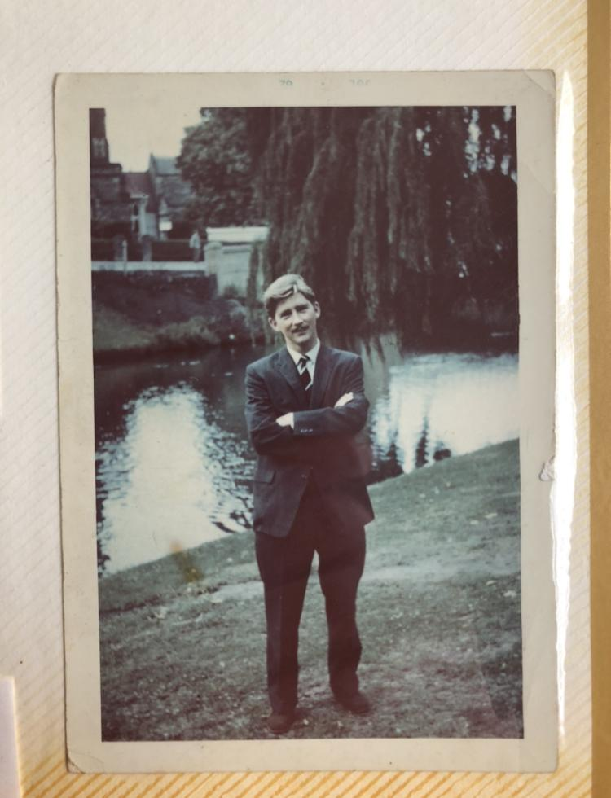
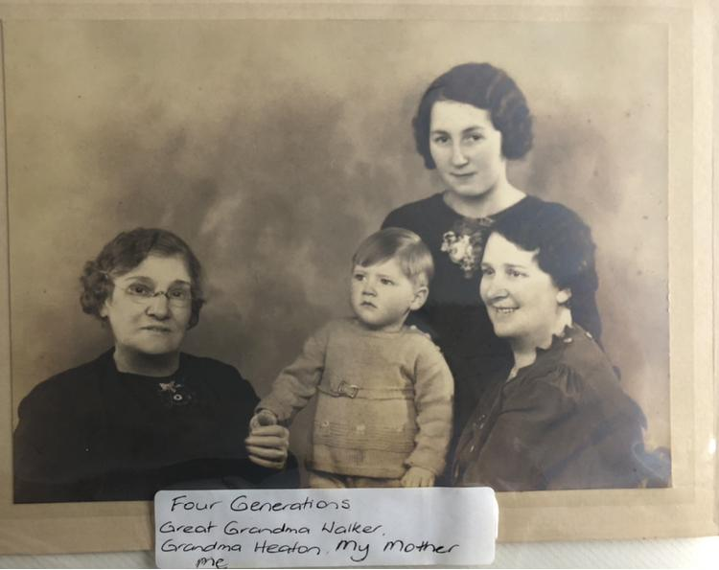
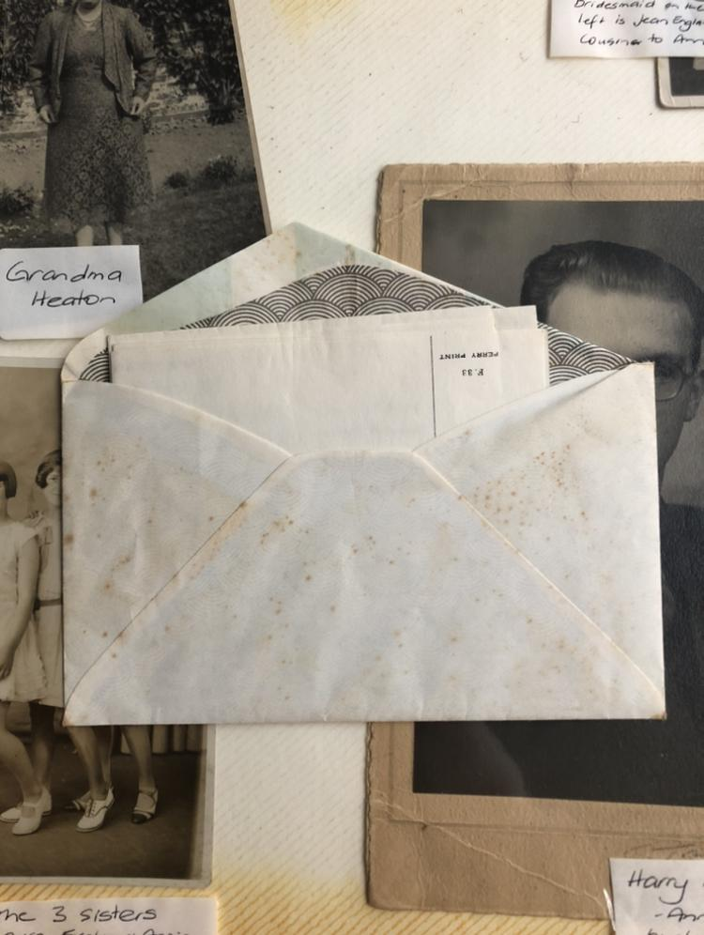

Kurt Varnedoe “Why Abstract Art?”

Kurt Varnedoe wrote a book in 2006 named “Pictures of Nothing: Abstract Art Since Pollock”, a portion of which, titled “Why Abstract Art?” was published in whitechapel’s documents of contemporary art book “Abstraction.” This extract was particularly useful to help me begin to answer this exact question, why do I prefer abstraction over a more illustrative documentation of my surroundings?

In a studio critique I was asked this question, and I was left unable to answer it with comprehensible language. I knew intrinsically why I was more drawn to it but was unable to find the right words to articulate that. Whilst the painters he talks about don't interest me, Varnedoe articulated how I feel about abstraction, especially in these quotes:

"This is one of abstraction's singular qualities, the form of enrichment and alteration of experience that expands our potential for expression and communication."

"We continually wind around something that never becomes any particular thing but itself, that has all of the complexity and energy that only IT has, and that did not exist before."

Particularly what stood out to me was the way he spoke about abstraction as a conduit for new ways to communicate, treating abstraction as something that holds a key to a new language of visual and emotional experiences. Slowly throughout this master’s project I will be refining my sensibilities and unpacking how to effectively translate my world and source material into abstract paintings. Whilst I do take shape and texture from very tangible figurative things, like concrete and buildings, I want them to evade identification in my work, to be nothing except what they appear to be in the work.

Vivienne Worn’s Ahoy II

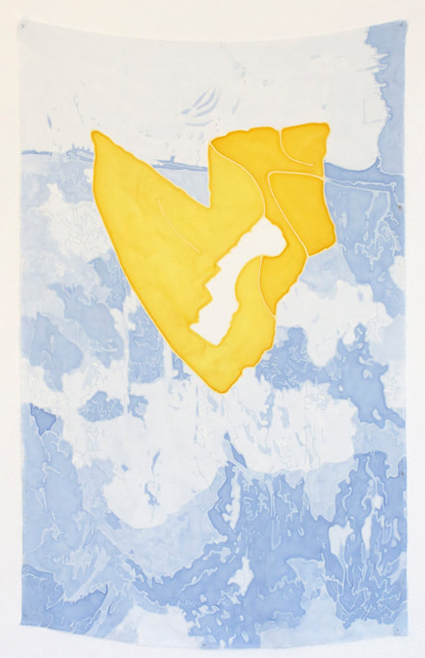
Vivienne Worn is a Tamaki Makaurau based artist who graduated with a masters from Elam in 2017, and has continued to make work that engages with found subject matter and source materials, and in her most recent series “retractings” (2020) at RM gallery, she has been working off of an archive.

For this exhibition, Worn explored the RM archive, full of exhibition invites, art, and ephemera collected since 2009. She created a series of extremely delicate acrylic paintings on silk with a variety of both large works floating in the middle of the room, and smaller works pinned to the walls.

One of those smaller works is Ahoy II, a mountainous range of soft icy blues and an inviting ‘V’ of warm yellow in the upper middle portion of the work.

What initially drew me into this work was the contrast in temperatures in the colours, and how the warm yellow feels luminous and alive, where the blues sit like arctic camouflage. What keeps me looking and what made me fall in love with this piece is the nuance but also the impact of the limited colour palette, and the delicacy of the nature of the paint on silk. Because Worn worked in washes there is little evidence of brushstrokes and you can see the paint has absorbed into the silk to create a unified surface texture.

Since she is working with archives and found source material I am once again brought to Worn’s paintings, and it creates a really nice connection between the project that I am undertaking and an artist whose work I have admired for quite some time. Worn created a smaller A4 version of this work called “Silks III”(2021) for the RM booth at the 2021 Auckland Art Fair that I purchased earlier in the year, so this work is quite a large influence of mine, especially since I get to see it all the time.

Image: 2020, Ahoy II, hand painted acrylic on silk, 800 x 500mm
http://www.vivienneworn.com/retracings-2020.html
Bibliography:

Artists on Artists: Rebecca Morris on Laura Owens, 2019. https://www.youtube.com/watch?v=u3gpuAd6hEM&t=1237s.
Blockprojects Gallery. David Thomas Moving Times, 2021. https://www.youtube.com/watch?v=hDO2hIVps8Y.
Cohen, Alina. “11 Emerging Artists Redefining Abstract Painting.” Artsy, January 6, 2020. https://www.artsy.net/article/artsy-editorial-11-emerging-artists-redefining-abstract-painting.
“FriedObjcthd.Pdf.” Accessed April 10, 2021. http://atc.berkeley.edu/201/readings/FriedObjcthd.pdf.
Gosling, Emily. “Why Are We so Drawn to Ritualism and the Occult?” ELEPHANT, February 13, 2020. https://elephant.art/why-are-we-so-drawn-to-the-occult-and-ritualism-13022020/.
Judy Millar. “Judy Millar.” Accessed April 10, 2021. https://judymillar.com/.
Lind, Maria, ed. Abstraction. Whitechapel: Documents of Contemporary Art. London: Whitechapel Gallery, 2013.
“Michele Araujo – BOMB Magazine.” Accessed April 10, 2021. https://bombmagazine.org/articles/michele-araujo.
Nontoxic Printmaking. “Non Toxic Printmaking.” Accessed April 10, 2021. http://nontoxic-printmaking.co.nz/non-toxic-printmaking/.
“OG14_MoMA.Pdf.” Accessed April 10, 2021. https://www.amysillman.com/wp-content/uploads/2020/12/OG14_MoMA.pdf.
Vivienne Worn. “Retracings, 2020.” Accessed April 10, 2021. http://www.vivienneworn.com/retracings-2020.html.
Print Council of Australia. “Roslyn Kean: Through Shadows.” Accessed April 10, 2021. https://www.printcouncil.org.au/roslyn-kean-through-shadows/.
“Sampling Ourselves: A Conversation with Alex Dodge : Art in Print.” Accessed April 10, 2021. https://artinprint.org/article/sampling-ourselves-a-conversation-with-alex-dodge/.
Taarati. “Paper Does Not Refuse Ink: Assessing the Boundaries of Printmaking as a Medium and Methodology, through an Expanded Conversation of New Zealand Print Histories.” Paper Does Not Refuse Ink (blog), April 30, 2010. http://paperdoesnotrefuseink.blogspot.com/2010/04/assessing-boundaries-of-printmaking-as.html.
———. “Paper Does Not Refuse Ink: Best Wishes Nora Gee.” Paper Does Not Refuse Ink (blog), April 30, 2010. http://paperdoesnotrefuseink.blogspot.com/2010/04/best-wishes-nora-gee.html.
———. “Paper Does Not Refuse Ink: The Renewing System.” Paper Does Not Refuse Ink (blog), February 6, 2010. http://paperdoesnotrefuseink.blogspot.com/2010/02/renewing-system.html.
———. “Paper Does Not Refuse Ink: Tracey Williams and Taarati Taiaroa in Conversation with Dan Arps.” Paper Does Not Refuse Ink (blog), April 30, 2010. http://paperdoesnotrefuseink.blogspot.com/2010/04/tracey-williams-and-taarati-taiaroa-in.html.
“The Company Your Mind Keeps: Catherine Haggarty Interviewed – BOMB Magazine.” Accessed April 10, 2021. https://bombmagazine.org/articles/the-company-your-mind-keeps-catherine-haggarty-interviewed/.
The Menil Collection. Conversation with Amy Sillman: Drawing in the Continuous Present, 2017. https://www.youtube.com/watch?v=BLOgc466nRk.
“Thesis: Jenny Harp « PRINTERESTING.” Accessed April 10, 2021. http://archive.printeresting.org/2015/03/22/thesis-jenny-harp/.
“Too Little and Too Much, All the Time.” Accessed April 10, 2021. https://bordercrossingsmag.com/article/too-little-and-too-much-all-the-time.
Trace. “Paper Does Not Refuse Ink: The Ephemera Collection.” Paper Does Not Refuse Ink (blog), February 6, 2010. http://paperdoesnotrefuseink.blogspot.com/2010/02/ephemera-collection.html.
Varnedoe, Kirk. Pictures of Nothing: Abstract Art since Pollock. The A.W. Mellon Lectures in the Fine Arts 2003. Princeton, NJ: Princeton University Press, 2006.
“Vivienne Worn – Retracings – RM.” Accessed April 10, 2021. https://rm.org.nz/vivienne-worn-retracings/.

